**Chapter 4**

**Differentiation of Functions of Several Variables**

**4.1 Functions of Several Variables**

**Section Exercises**

**For the following exercises, evaluate each function at the indicated values.**

1. . Find , 

Answer:

3. The volume of a right circular cylinder is calculated by a function of two variables, , where  is the radius of the right circular cylinder and  represents the height of the cylinder. Evaluate  and explain what this means.

Answer: . This is the volume when the radius is  and the height is .

**For the following exercises, find the domain of the function.**

5. 

Answer: All points in the -plane

7. 

Answer: 

9. 

Answer: All real ordered pairs in the -plane of the form

**Find the range of the functions.**

11. 

Answer: 

13. 

Answer: The set 

**For the following exercises, find the level curves of each function at the indicated value of to visualize the given function.**

15. , 

Answer: , a hyperbola

17. 

Answer: , a line; , line through the origin

19. 

Answer:  ; three lines

21. 

Answer: 

23. 

Answer: 

25. 

Answer: 

27. 

Answer: 

29.   any constant

Answer: The level curves are parabolas of the form 

**For the following exercises, find the vertical traces of the functions at the indicated values of  and *y*, and plot the traces.**

31. 

Answer: , a curve in the -plane with rulings parallel to the -axis

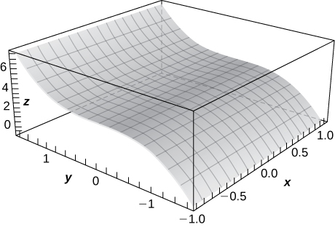

**Find the domain of the following functions.**

33. 

Answer: 

35. 

Answer: 

37. 

Answer: All points in -space

**For the following exercises, plot a graph of the function.**

39. 

Answer:

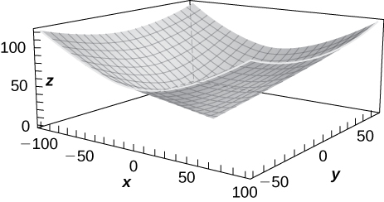

41. Use technology to graph .

Answer:

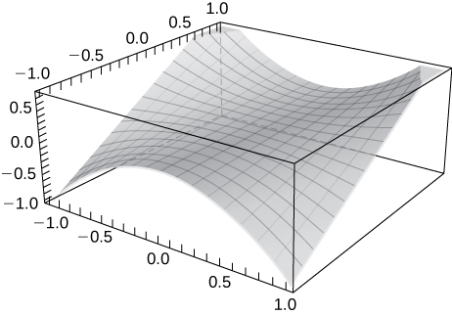

**Sketch the following by finding the level curves. Verify the graph using technology.**

43. 

Answer:

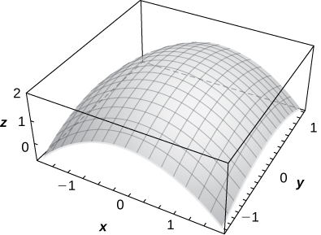

45. 

Answer:

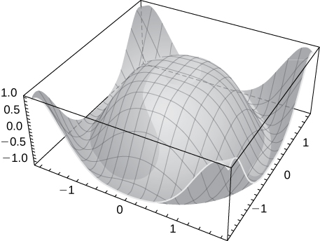

47. Describe the contour lines for several values of ** for .

Answer: The contour lines are circles.

**Find the level surface for the functions of three variables and describe it.**

49. 

Answer:  a sphere of radius 

51. 

Answer:  a hyperboloid of one sheet

**For the following exercises, find an equation of the level curve of  that contains the point *.***

53. 

Answer: 

55. 

Answer: 

57. A thin plate made of iron is located in the -plane. The temperature in degrees Celsius at a point is inversely proportional to the square of its distance from the origin. Express  as a function of.

Answer: 

59. Refer to the preceding problem. Find the level curves for  and describe what the level curves represent.

Answer:   The level curves represent circles of radii  and 

This file is copyright 2016, Rice University. All Rights Reserved.